AMERICAN INTERNATIONAL UNIVERSITY-BANGLADESH


Semester: Spring 2022-23
Topic: Football Tournament Management

Group Members : (group no-09)

NAME | ID
Md.Firoz Mahmud Saikat | 22-47363-2
Md.Sakibul Hoque | 22-47370-2
Jaber Bhuiyan | 22-47378-2
Atik Shahrier Rakir | 22-48252-2

Submitted to: MD SAJID BIN-FAISAL Course: Introduction to Database Section : K

Table of Contents : page no :
- Case Study 1
- ER diagram 2
- Normalization 3-8
- Finalization 9
- Table Creation and value insert 10-17
- Query 18-21
- Joining query 22
- Sub-query(single-row,multiple-row) 23-24
- Aggregate Fuction query 25
- View 25-26

Case Study :
In a football tournament management system, there are many football teams. One team may have many players, but a player can only be a member of one team. A team is identified by a team ID, and the system also stores the team name, coach name, and the city where the team is located.
Each player is identified by a player ID and has a name, position, and nationality. The system also stores information about the player's date of birth, height, and weight.
The system also stores information about football matches. A match is identified by a match ID, and each match involves two teams. For each match, the date, time, location, and the final score of the match are stored. Home Match and Away match can be generalized as match.
In addition to matches, the system also stores information about football tournaments. A tournament is identified by a tournament ID and has a name, start date, and end date. Each tournament consists of multiple matches, and each match is associated with a tournament. Tournament can be specialized into World cup, Euro and Copa America.
A football player may also receive awards, such as the player of the match, player of the season, or golden boot. Each award is identified by an award ID, and the system stores the name of the award, the player who received it, and the date when it was awarded.
To identify a football stadium, the system stores stadium ID, name, and location. Each stadium can host many matches, but a match can only take place in one stadium.
Finally, the system also stores information about the football leagues. Each league is identified by a league ID and has a name, start date, and end date. Each league consists of multiple teams, and each team can participate in many leagues. The unique property of each league is the league number.

ER Diagram:
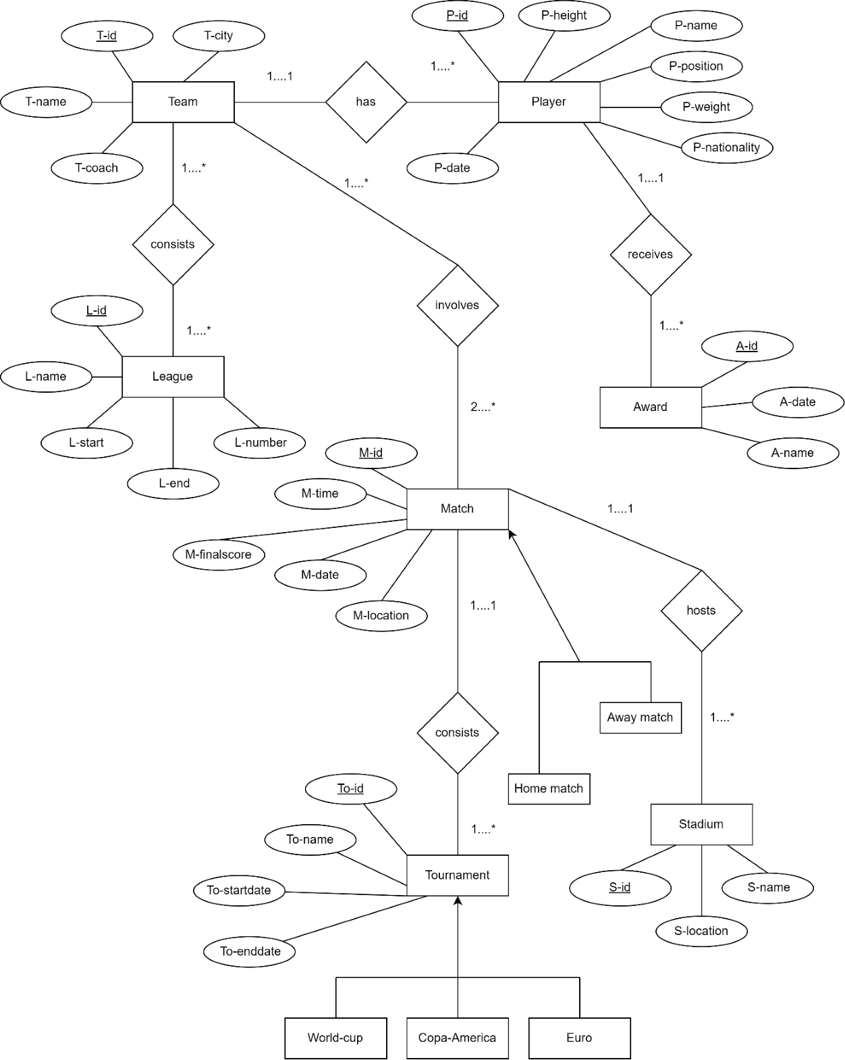

Normalization:
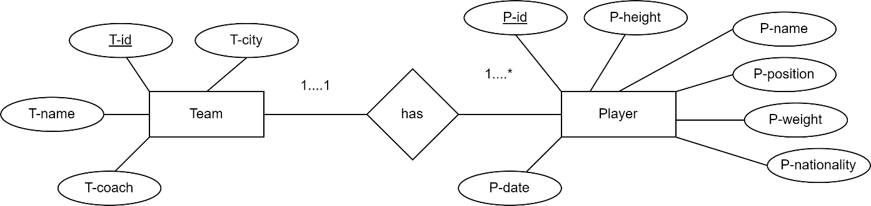

UNF:

(Has):
T-id , T-name, T-city, T-coach name, P-id, P-height, P-name, P-position, P-weight, P- nationality, P-date

1NF:
T-id , T-name, T-city, T-coach name, P-id, P-height, P-name, P-position, P-weight, P-nationality, P-date

2NF:
1.T-id ,T-name, T-city, T-coach name
2.P-id(PK), P-height, P-name, P-position , P-weight, P-nationality, P-date, T-id(FK)

3NF:

As same as 2NF

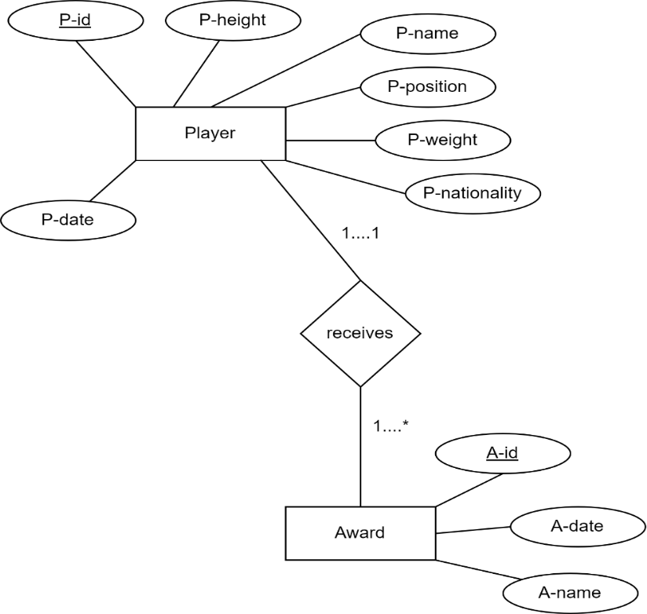

UNF:

(Receives):

1NF:

P-id, P-height, P-name, P-position, P-weight, P-nationality, P-date, A-id, A-date, A-name.

P-id, P-height, P-name, P-position, P-weight, P-nationality, P-date, A-id , A-date, A-name.

2NF:
1.P-id, P-height, P-name, P-position, P-weight, P-nationality, P-date
2.A-id(PK), A-date, A-name, P-id(FK)

3NF:
As same as 2NF

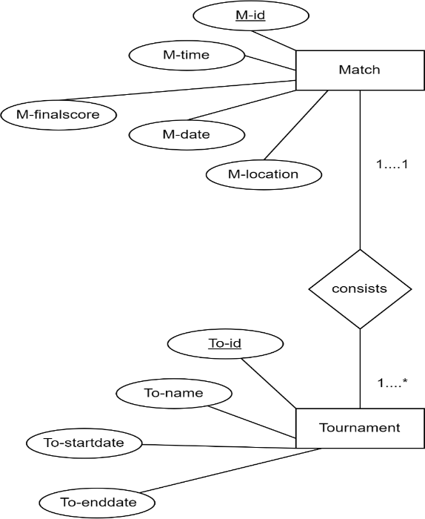

UNF:

(Consists):
M-id, M-time, M-finalscore, M-date, M-location, To-id, To-name, To-startdate,
To-enddate

1NF:
M-id, M-time, M-finalscore, M-date, M-location, To-id, To-name, To-startdate, To-enddate

2NF:

- M-id, M-time, M-fainalscore, M-date, M-location
- To-id(PK), To-name, To-startdate, To-enddate, M-id(FK)

3NF:
As same as 2NF

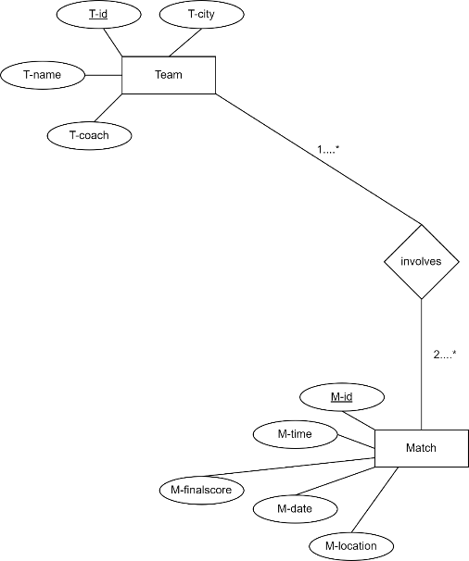

UNF:
(Involves):
T-id, T-name, T-city, T-coach name, M-id, M-time, M-data, M-location, M-finalscore.

1NF:

2NF:

3NF:

T-id, T-name, T-city, T-coach name, M-id, M-time, M-data, M-location, M-finalscore.

1.T-id, T-name, T-city, T-coach name.
2.M-id, M-time, M-data, M-location, M-finalscore.
3.T-id (PK), M-id (FK).

As same as 2NF

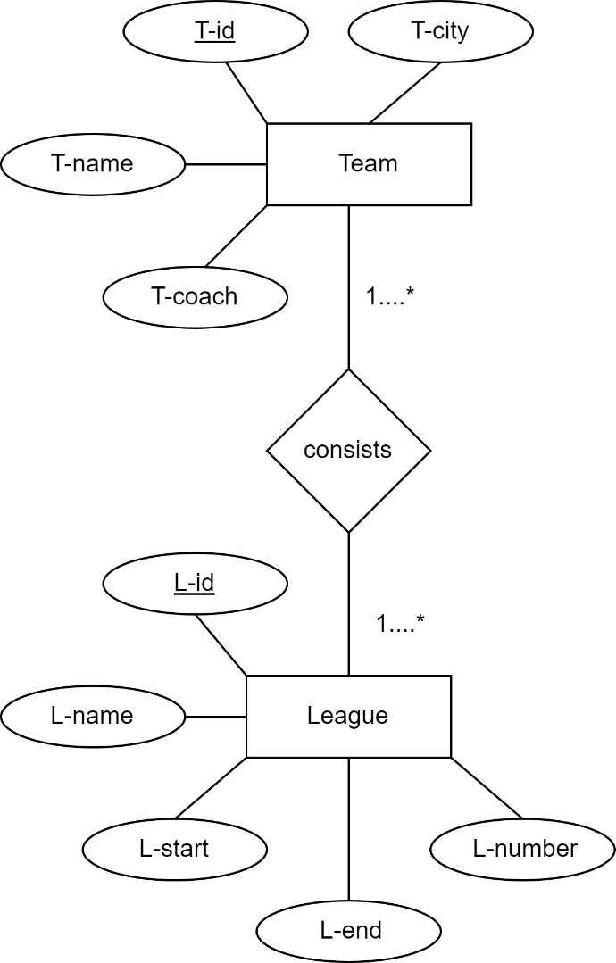

UNF:
(Consists):
T-id, T-name, T-city, T-coach name, L-id, L-name,L-start, L-end, L-number.

1NF:

2NF:

T-id, T-name, T-city, T-coach name, L-id, L-name, L-start, L-end, L-number.

- T-id, T-name, T-city, T-coach name.
- L-id, L-name, L-start, L-end, L-number.
- T-id (PK), L-id (FK).

3NF:
As same as 2NF.

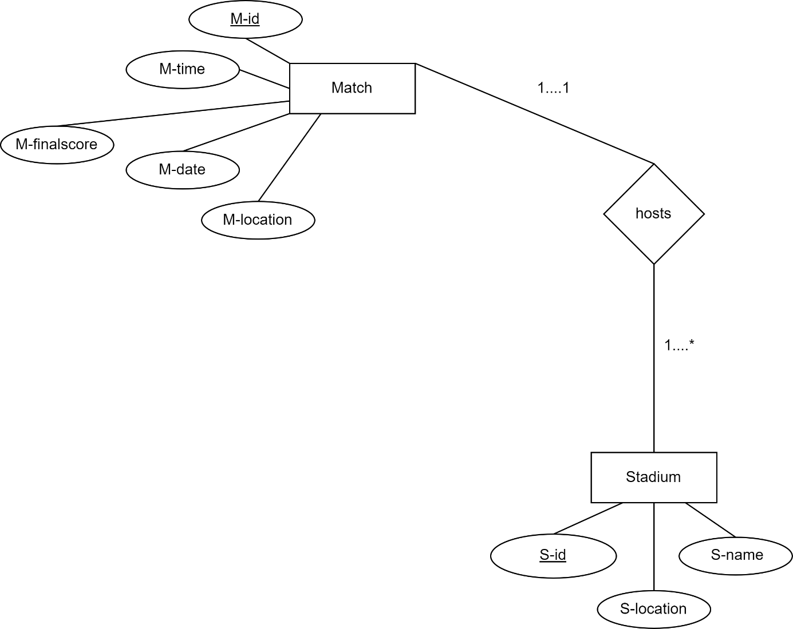

UNF:
(Hosts):
M-id, M-time, M-data, M-location, M-finalscore, S-id, S-name, S-location.

1NF:

2NF:

M-id, M-time, M-data, M-location, M-finalscore, S-id, S-name, S-location.

- M-id, M-time, M-data, M-location, M-finalscore.
- S-id (PK), S-name, S-location, M-id (FK). 3NF:
As same as 2NF.

Finalization:

- T-id, T-name, T-city, T-coach name.
- P-id(PK), P-height, P-name, P-position, P-weight, P-nationality, P-date, T-id(FK) .
- P-id, P-height, P-name, P-position, P-weight, P-nationality, P-date.
- A-id(PK), A-date, A-name, P-id(FK).

- M-id, M-time, M-data, M-location, M-finalscore.
- T-id (PK), L-id (FK).
- L-id, L-name, L-start, L-end, L-number.
- T-id (PK), M-id (FK).
- To-id(PK), To-name, To-startdate, To-enddate, M-id(FK).
- S-id (PK), S-name, S-location, M-id (FK).

Table Creation and value insert:
- create table team(team_id number (10) primary key, team_name varchar(50), team_coach_name varchar(50), team_city varchar(50));

describe team
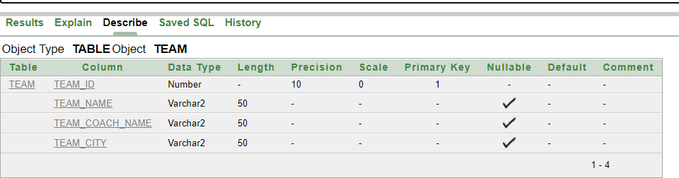

insert into team values (200010, 'Argentina','Lionel Scaloni','Buenos Aires') insert into team values (200011, 'Brazil','Tite','Brasília')
insert into team values (100010, 'Japan','Hajime Moriyasu','Tokyo') insert into team values (300010, 'France','Didier Deschamps','Paris') insert into team values (300011, 'Portugal','Roberto Martínez','Lisbon')
select * from team

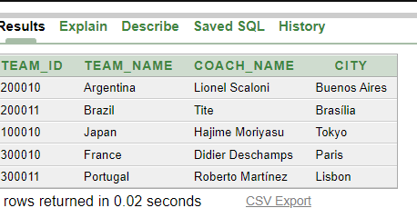

- create table player(player_id number(10) primary key, player_name varchar(100), position number (10),nationality varchar(100),date_of_birth varchar(100),height number(10),weight number(10),team_id number (10));

alter table player modify(height varchar(100)) alter table player modify(weight varchar(100))

describe player
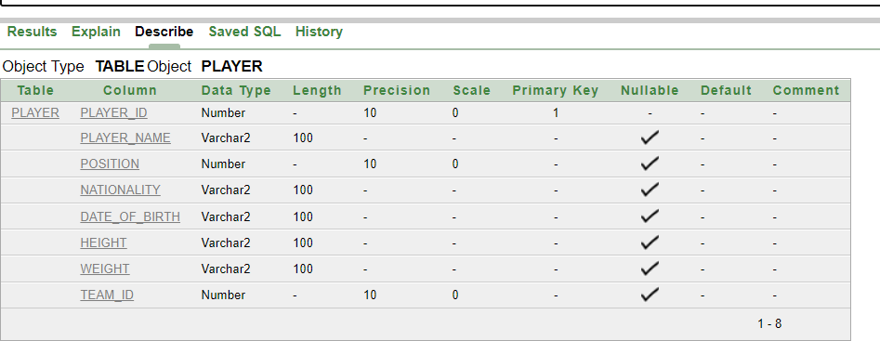

insert into player values (0010, 'Messi', 10,'Argentine','24-06-1987','1.7m','72kg',200010) insert into player values (0011, 'Neymar', 10,'Brazilian','05-19-1992','1.75m','68kg',200011) insert into player values (0009, 'Kaoru Mitoma', 09,'Japnese','20-05- 1997','1.78m','73kg',100010)
insert into player values (0007, 'Kylian Mbappe', 07,'French','20-12- 1998','1.78m','75kg',300010)
insert into player values (1007, 'Cristiano Ronaldo', 07,'Portuguese','05-02- 1985','1.87m','85kg',300011)

select * from player
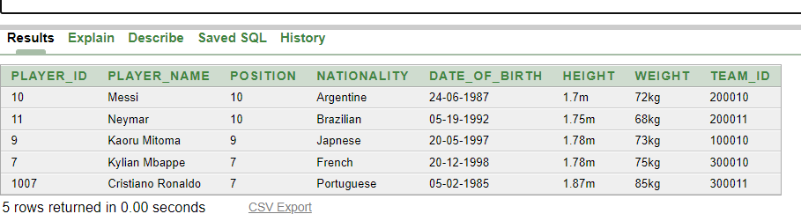

- create table player_info(player_id number(10) primary key, player_name varchar(100), position number (10),nationality varchar(100),date_of_birth varchar(100),height varchar(100),weight varchar(100));

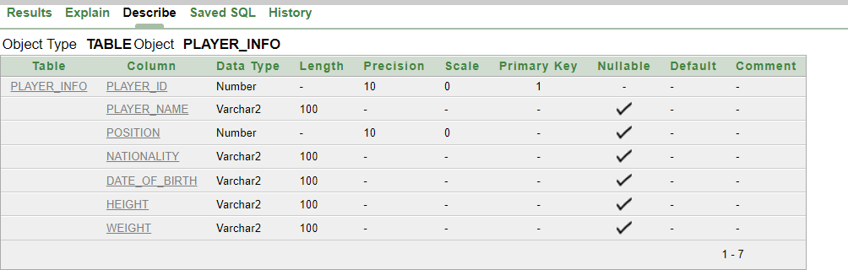
describe player_info

insert into player_info values (0010, 'Messi', 10,'Argentine','24-06-1987','1.7m','72kg') insert into player_info values (0011, 'Neymar', 10,'Brazilian','05-19-1992','1.75m','68kg')
insert into player_info values (0009, 'Kaoru Mitoma', 09,'Japnese','20-05-1997','1.78m','73kg') insert into player_info values (0007, 'Kylian Mbappe', 07,'French','20-12-1998','1.78m','75kg') insert into player_info values(1007, 'Cristiano Ronaldo', 07,'Portuguese','05-02- 1985','1.87m','85kg')

select*from player_info
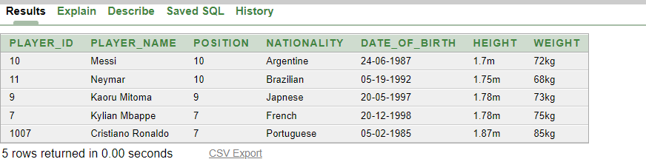

- create table award(award_id number(4) primary key, award_name varchar(100),player_id number (15),awards_date varchar(50));

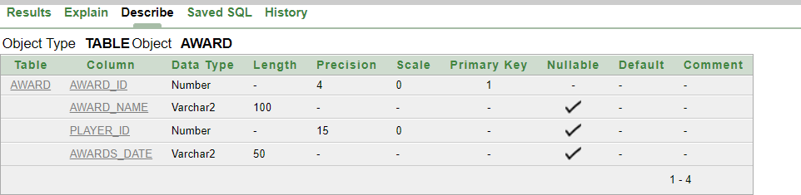
describe award

insert into award values (6931, 'Ballon d_Or',0010,'17-10-2022') insert into award values (8975, 'Golden Boot',0007,'17-10-2022') insert into award values (6831,'Golden Glove',1502,'17-10-2022')

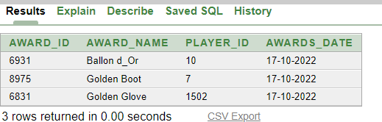
select* from award

- create table match(match_id number(10) primary key,match_time varchar(100),match_location varchar(100),match_date varchar(100),match_finalscore varchar(100));

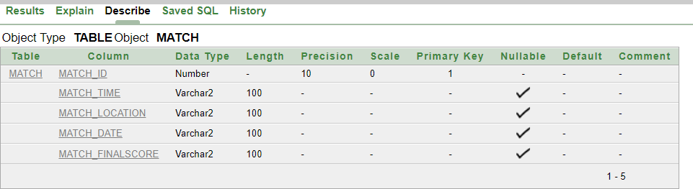
describe match

insert into match values (1101,'10:30pm','Estadio Monumental','01-06-2023','5-2');

insert into match values (1102,'10:00pm','Parc des Princes','08-06-2023','7-4'); insert into match values (1104,'10:30am','Stade de France','11-06-2023','6-3'); select * from match
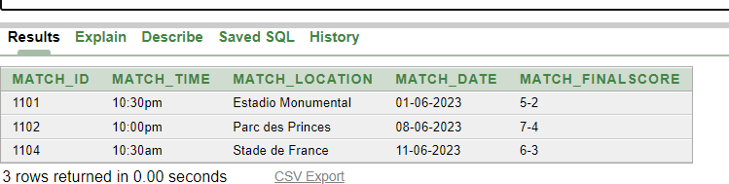

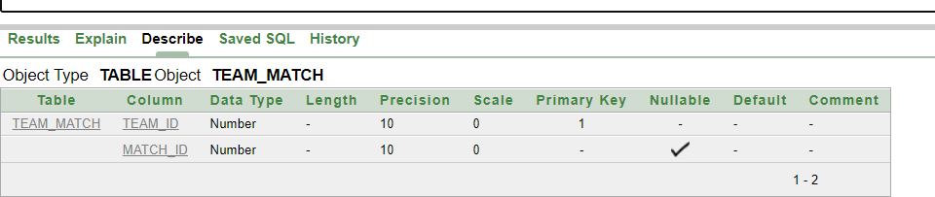
- create table team_match (team_id number (10) primary key,match_id number(10)); describe team_match

insert into team_match values (200010,1101) insert into team_match values (200011,1102) insert into team_match values (100010,1109) insert into team_match values (300010,1104) insert into team_match values (300011,1111)

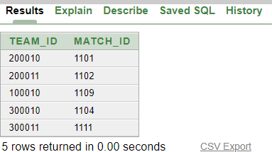
select * from team_match

- create table league(league_id number (10) primary key, league_name varchar(100),start_date varchar (100), end_date varchar (100), league_number varchar(100))

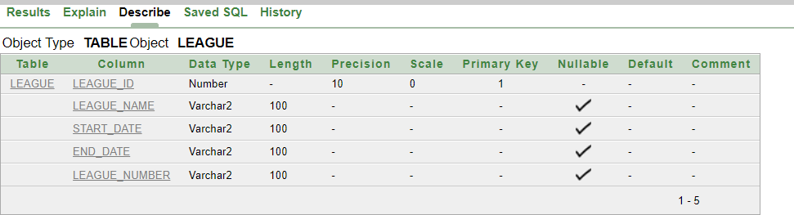
describe league

insert into league values (3301,'La liga','12-08-2023','04-06-2024', '22-23'); insert into league values (3302,'Bundesliga','10-07-2023','07-05-2024', '22-23'); insert into league values (3303,'Ligue1','21-09-2023','10-07-2024', '22-23');
select* from league
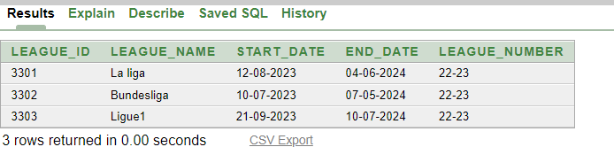

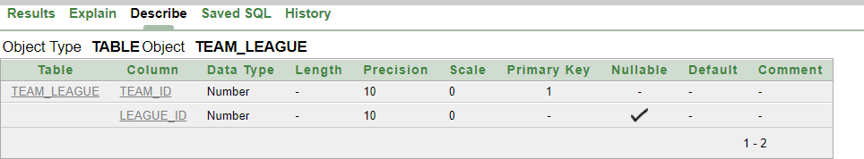
- create table team_league (team_id number (10) primary key,league_id number (10)) describe team_league

insert into team_league values (200010,3301) insert into team_league values (200011,3302) insert into team_league values (100010,3303) insert into team_league values (300010,3306) insert into team_league values (300011,3307)

select * from team_league

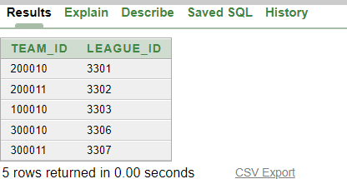

- create table tournament ( tournament_id number(10) primary key, tournament_name varchar(100), start_date varchar (100), end_date varchar (100),match_id number(10))

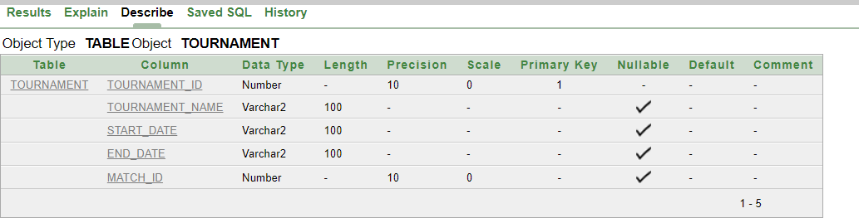
describe tournament

insert into tournament values (5501, 'World Cup', '20-11-2022', '18-12-2022',1101)
insert into tournament values (5502, 'Euro', '14-06-2024', '14-07-2024',1102)
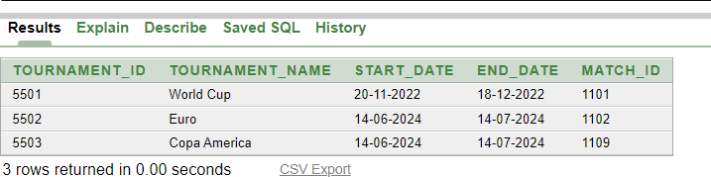
insert into tournament values (5503, 'Copa America', '14-06-2024', '14-07-2024',1109) select * from tournament

- create table stadium( stadium_id number(10) primary key,stadium_name varchar(100),stadium_location varchar(100),match_id number(10))

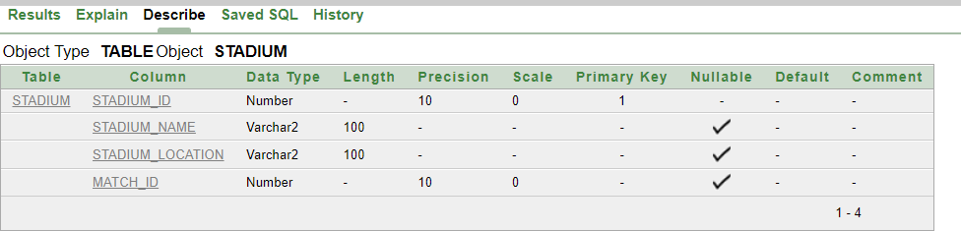
describe stadium

insert into stadium values (6601, 'Camp Nou','Barcelona Spain',1101) insert into stadium values (6602, 'Santiago Bernabeu','Madrid Spain',1102)
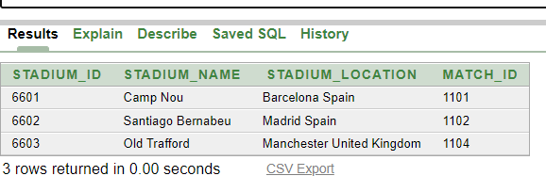
insert into stadium values (6603, 'Old Trafford','Manchester United Kingdom',1104) select * from stadium

Query:

- Show the player_id,player_name,position and team_id from the player_table.
  - select player_id,player_name,position,team_id from player

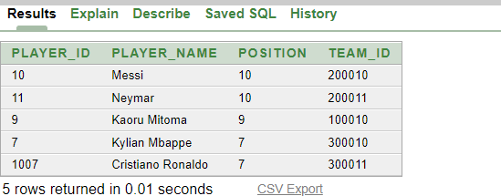

- Show all data from the team_table .
  - select * from team

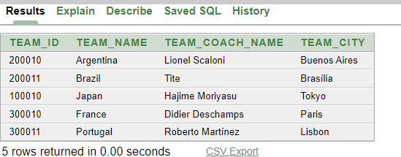

- Show the detail description of the player_info table
  - describe player_info

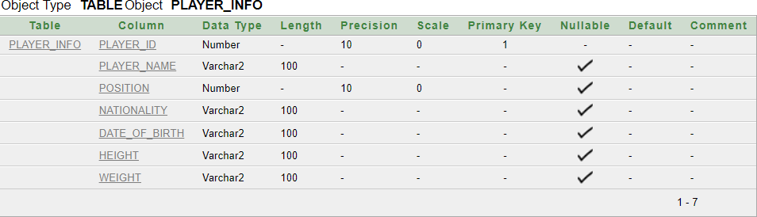

- Show the concatenation result of the player's name and date of birth and labeling it as "player" using the "player_info" table

  - select player_name||date_of_birth AS "player" from player_info

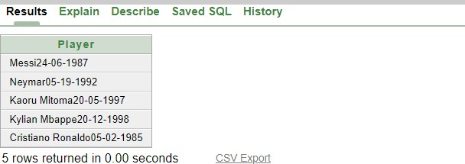

- show the concatenation result of award name,use the string "is a" and award id as "Award Details"from the table award

  - select award_name||' '||'is a'||' '||award_id AS "Award Details" from award

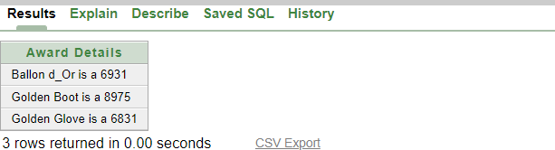

- show match_id, match_time, and match_location from the table match, where the match_location is 'Estadio Monumental'
  - select match_id,match_time,match_location from match
where match_location='Estadio Monumental';

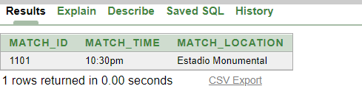

- show the league_id and league_number from the table league, where the league_id is between 3302 and 3303
  - select league_id,league_number from league
where league_id between 3302 and 3303;



Joining Query:
- Equi-joins joining
Write a query using Equijoins joining that retrieves the team name, team city, team ID, player ID, player nationality, and player team ID, by joining the "team" and "player" tables on the team ID.
  - SELECT team.team_name, team.team_city, team.team_id, player.player_id, player.nationality, player.team_id
FROM team, player WHERE team.team_id=player.team_id;
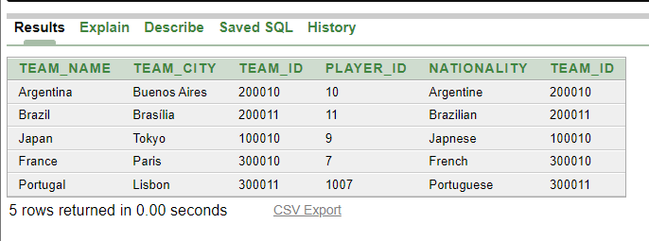

- Outer joining
Show team_name,team_city,team_id from team table and team_id,nationality from player table using outer joining condition.
  - SELECT t.team_name, t.team_city, t.team_id, p.team_id, p.nationality FROM team t, player p
WHERE t.team_id(+) = p.team_id ORDER BY t.team_id;
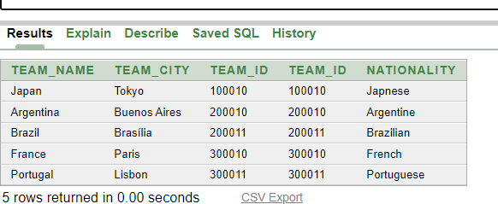

Sub-query:
- Single Row Subquery
Show player_name ,player_id from player table where the player’s weight is greater than the weight of the player who plays in the position with the id of 9.
  - SELECT player_name,player_id FROM player
WHERE weight>
(SELECT weight
FROM player WHERE position=9);
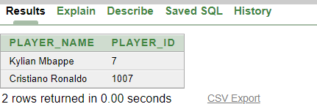

- Single Row Subquery
Show player_name,player_id,position from player_info table where the player’s position is equal to the minimum position value in the player_info table.
  - SELECT player_name,player_id,position FROM player_info
WHERE position= (SELECT MIN(position)
FROM player_info);
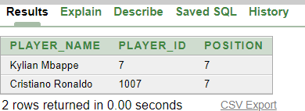

- Multiple Row Subquery
Show player_id,player_name,team_id,nationality from player table where the team id is less than any team id associated with a French player and the player nationality is not French.
  - SELECT player_id,player_name,team_id,nationality FROM player
WHERE team_id< any (SELECT team_id
FROM player WHERE nationality = 'French') AND nationality <> 'French';
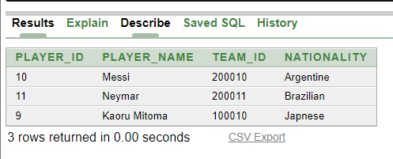
- Multiple Row Subquery
Show award_id ,award_name,awards_date from award table where the award_id obtained from the subquery that selects the award_id from the award table with an award name other than “Golden Boot”
  - SELECT award_id ,award_name,awards_date FROM award WHERE award_id< any (SELECT award_id FROM award
WHERE award_name = 'Golden Boot') AND award_name <> 'Golden Boot';

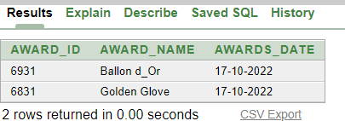

Aggregate Fuction query:
show the Maximum and Minimum Positions of Players.
  - SELECT MAX(position),MIN(position) FROM player
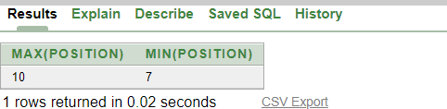

View:

Create a View of Dream11 Players with Position 10
  - CREATE VIEW dream11
AS SELECT player_id, player_name,position,height FROM player
WHERE position=10;
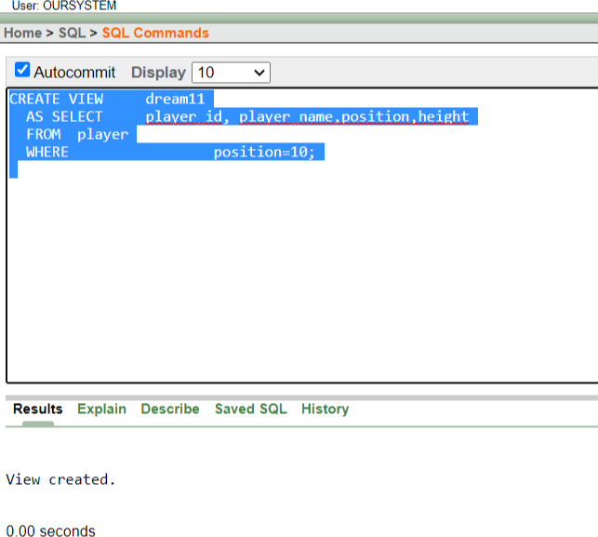

Show the detail description of the dream11 table
  - describe dream11
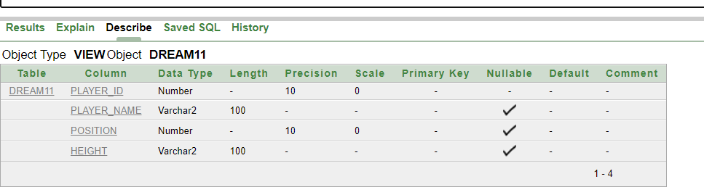

Show all data from the dream11_table
  - select*from dream11

